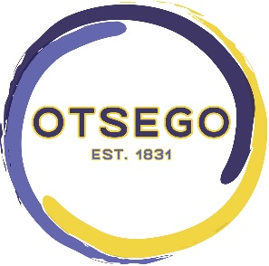
CITY OF OTSEGO
Otsego, MI 49078
269-692-3391
269-692-2643 (F)
WWW.CITYOFOTSEGO.ORG

2021 Planning Commission Summary

The Planning Commission had a limited agenda throughout 2021. Development was slowed in response to the COVID pandemic and economic uncertainties. Throughout the year we were able to approve multiple applications and add a text amendment that are detailed below.

Site Plan Amendment
Peloton (595 E. Allegan St.) - Peloton added a small addition on the back of their shop and expanded their parking lot.
Prime Solutions (610 S. Platt St.) - Prime Solutions added a concrete slab that will be fenced in with a privacy fence that will hold unfinished materials.

Special Land Use Permit
Prime Solutions (610 S. Platt St.) - Prime Solutions received a SLUP for Vehicle Major and Minor Repair Facilities. This will allow the owner to refurbish classic cars with new battery motors and sell them off site. They have a license with the State of Michigan to sell vehicles but there cannot be any cars parked for sale outside of the building and privacy fenced enclosed in area.

Text Amendment
Wellhead Protection Site Plan Additions- The City of Otsego recently conducted a Wellhead Protection Program through an EGLE grant. A result of that program is an ordinance that protects the groundwater wellhead. Part of that Ordinance includes site plan developmental guidelines that includes an EGLE Checklist. This checklist is now a requirement with all new development site plans.

2022 Goals
Training- There are many new Planning Commissioners that have never received any formal training related to their role.
Zoning Ordinance Updates- There are a few updates that should be addressed within the Zoning Ordinance.
Master Plan- The Master Plan is overdue and will need to be updated in the coming future. COVID delayed this possibility in 2021.

Aaron Mitchell
Zoning Administrator

